Develop A Web Application Using Node-RED

|  |  |
| --- | --- |
| Name | Aparna Bhuvanesvari L |
| Register Number | 710719106006 |
| ProjectName | Project-IoTBasedSafetyGadgetForChild  SafetyMonitoring& Notification |
| MaximumMarks | 2 Marks |

Steps Followed:

* 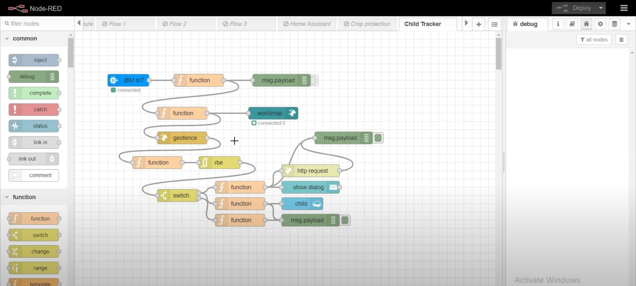Opened a Node-RED project
* Added code to get child location in python

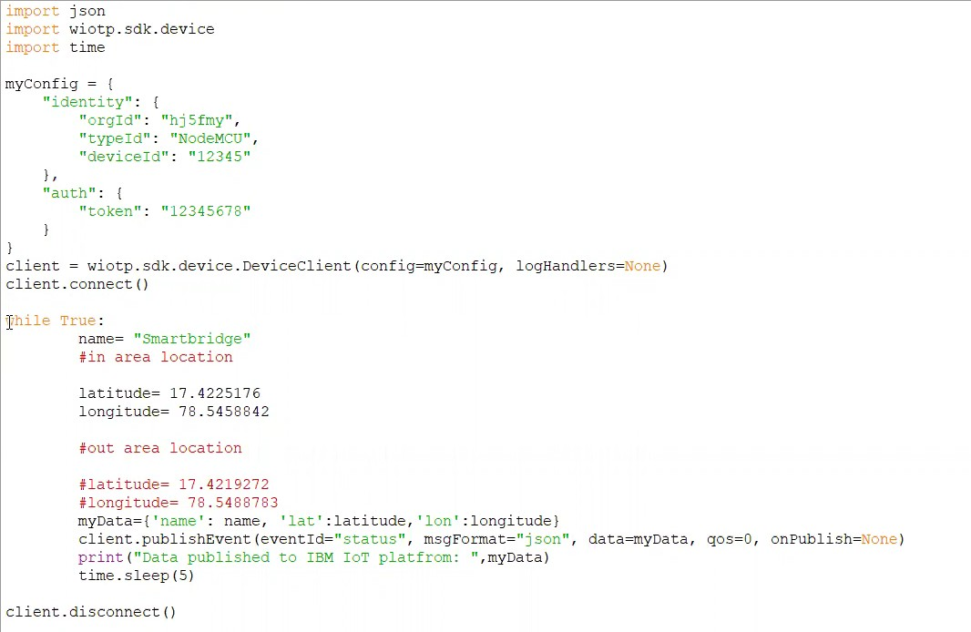

* 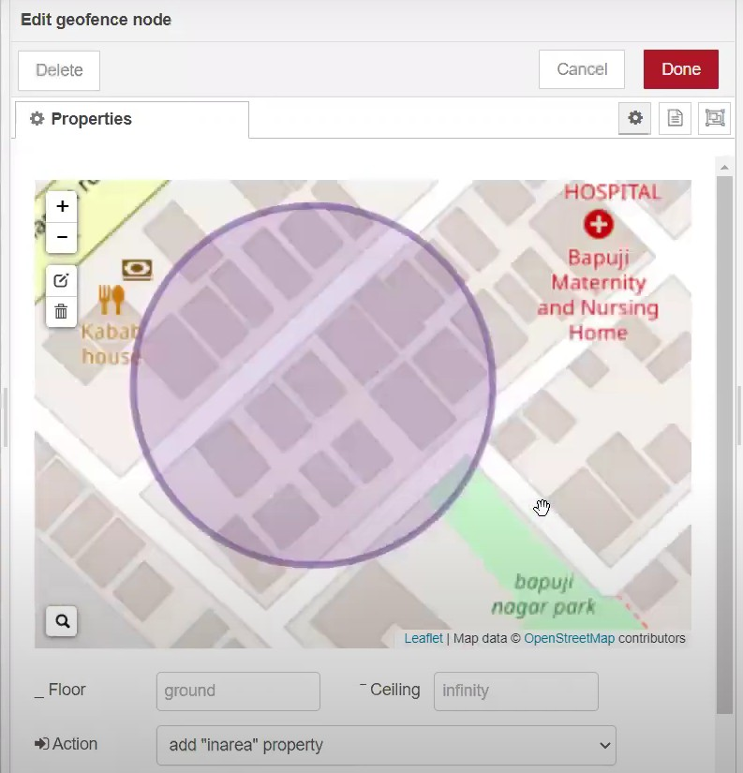Created the Geo Fence
* 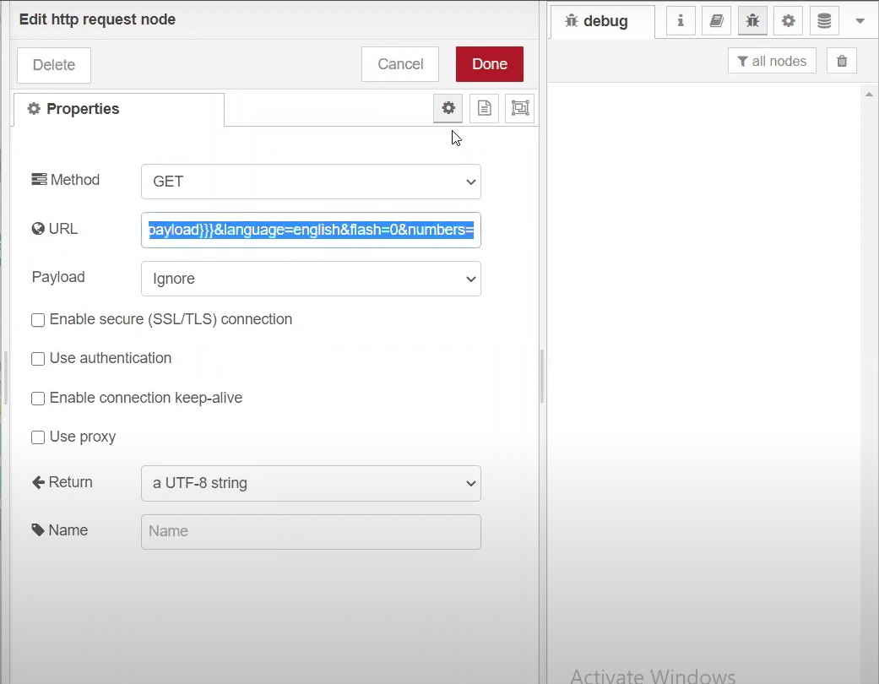Editing the HTTP Request URL
* Located the child

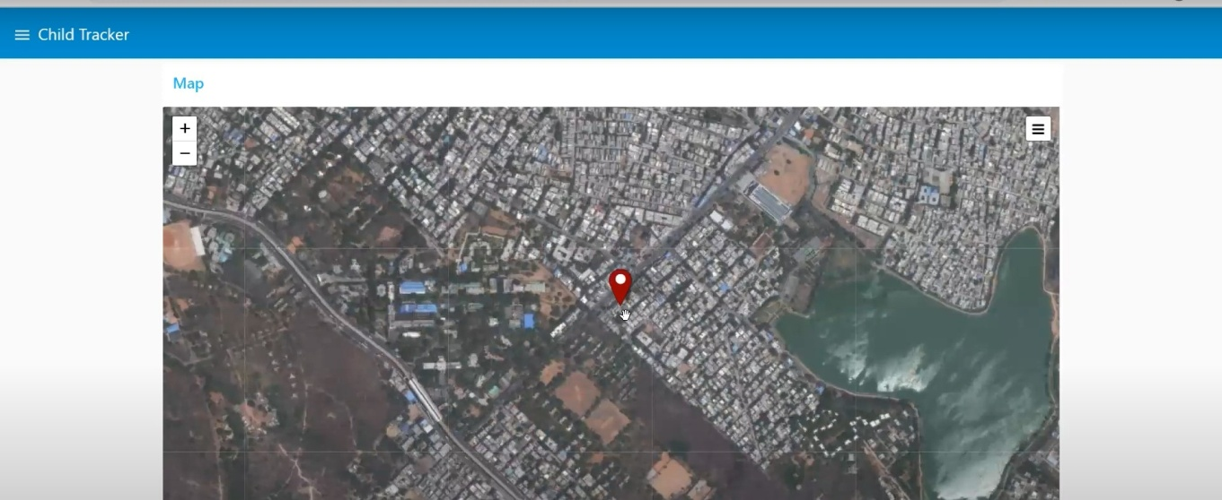

* 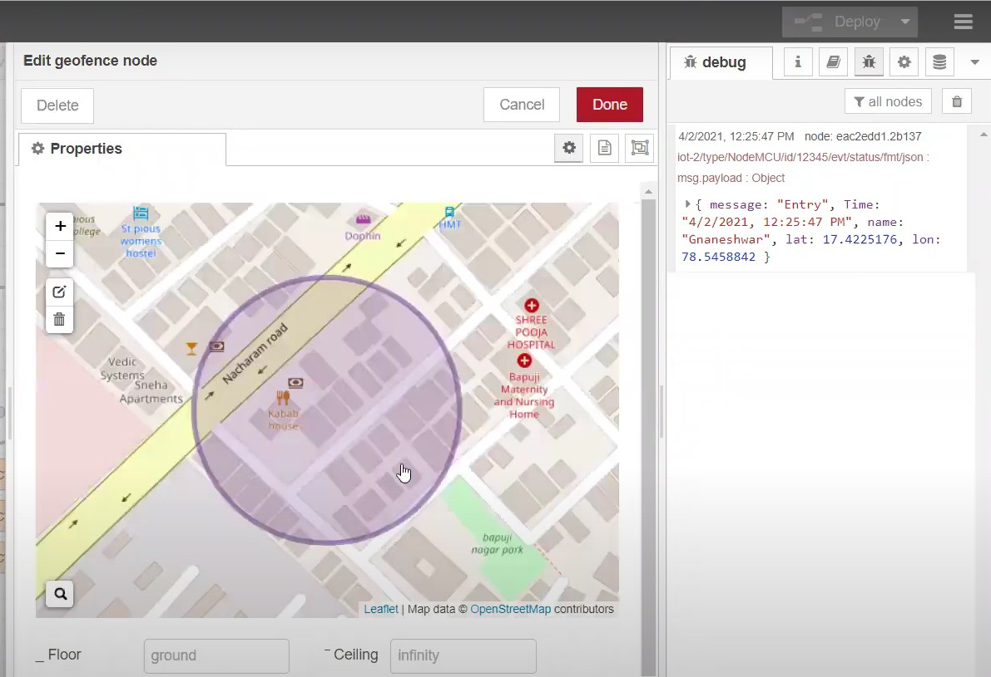Created the geo fence node
* Python script sending requests to IBMCloud

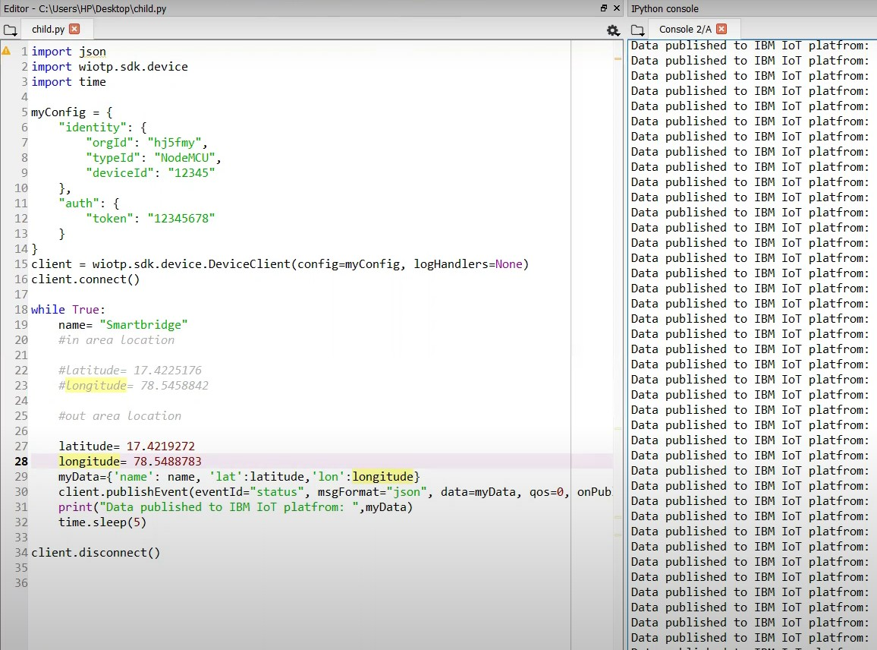

* 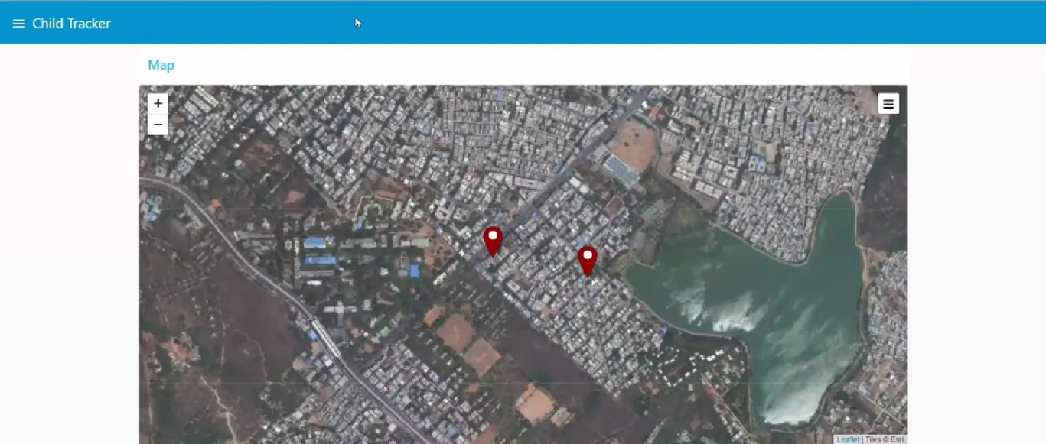After running the script, the web UI shows “Person is not in the particular area”

**Result:**

Successfully developed a web application using Node-RED.